Workflow Functional Document

Application: | NGERP-CENTRA
WorkFlow: | Quote To Cash
WorkFlow Item Name: | VAT Transfer

Description
This workflow used to change the invoice type from undeclared to declared NTA AP/AP Invoice into the HQoW and ROW systems with manual process

Work Flow Process:
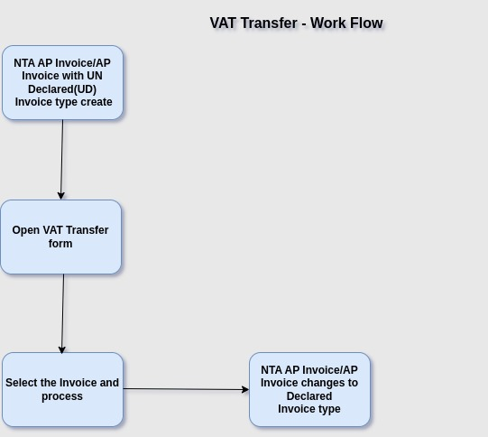

Business Rules:

- A Non-Trade Accounts Payable (AP) Invoice is an invoice is an invoice for expenses or obligations that do not arise from the core business activities or procurement of goods and services intended for resale or production.
- If the user initially chooses the 'Undeclared' type, they can change it to a 'Declared' type by using and processing a VAT transfer form.

